**INTERFAZ DEL PROGRAMA PARA ANALIZAR SOBRE ANCHOS Y ESTABILIZAR TALUDES.**

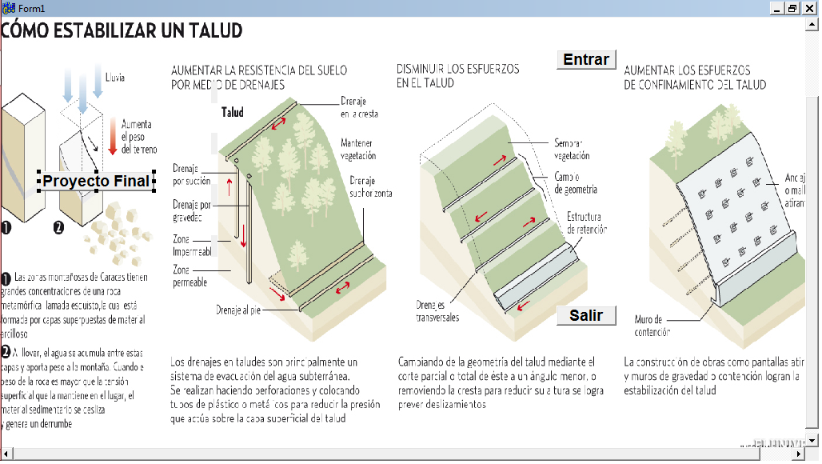

**PROGRAMACION**

//---------------------------------------------------------------------------

#include <vcl.h>

#pragma hdrstop

#include "Unit1.h"

#include "Unit2.h"

//---------------------------------------------------------------------------

#pragma package(smart_init)

#pragma resource "*.dfm"

TForm1 *Form1;

//---------------------------------------------------------------------------

__fastcall TForm1::TForm1(TComponent* Owner)

: TForm(Owner)

{

}

//---------------------------------------------------------------------------

(**programacion del button1 [proyecto final])**

void __fastcall TForm1::Button1Click(TObject *Sender)

{

Label1->Caption=" Sánchez Castellanos";

Label2->Caption=" Facultad de Ingeniería";

Label3->Caption=" Programación ";

Label4->Caption=" Proyecto Individual Final ";

}

//---------------------------------------------------------------------------

(**programacion del button3 [salir])**

void __fastcall TForm1::Button3Click(TObject *Sender)

{

Close();

}

//---------------------------------------------------------------------------

(**programacion del button2 [entrar])**

void __fastcall TForm1::Button2Click(TObject *Sender)

{

Form2->Show();

}

//---------------------------------------------------------------------------

**MENU**

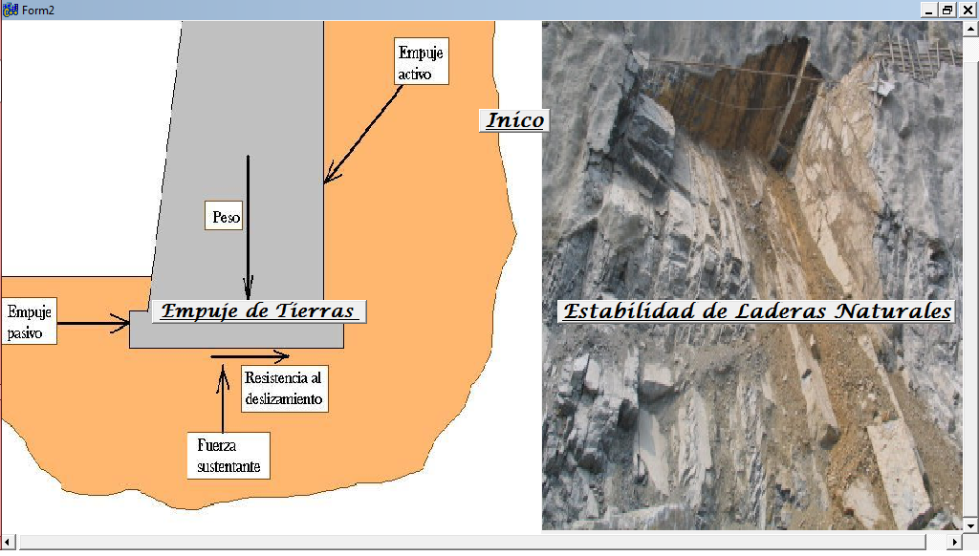

**PROGRAMACIÓN**

//---------------------------------------------------------------------------

#include <vcl.h>

#pragma hdrstop

#include "Unit1.h"

#include "Unit2.h"

#include "Unit3.h"

#include "Unit4.h"

//---------------------------------------------------------------------------

#pragma package(smart_init)

#pragma resource "*.dfm"

TForm2 *Form2;

//---------------------------------------------------------------------------

__fastcall TForm2::TForm2(TComponent* Owner)

: TForm(Owner)

{

}

//---------------------------------------------------------------------------

void __fastcall TForm2::Button3Click(TObject *Sender)

{

Form1->Show();

}

//---------------------------------------------------------------------------

void __fastcall TForm2::Button1Click(TObject *Sender)

{

Form3->Show();

}

//---------------------------------------------------------------------------

void __fastcall TForm2::Button2Click(TObject *Sender)

{

Form4->Show();

}

//---------------------------------------------------------------------------

**EMPUJE DE TIERRAS**

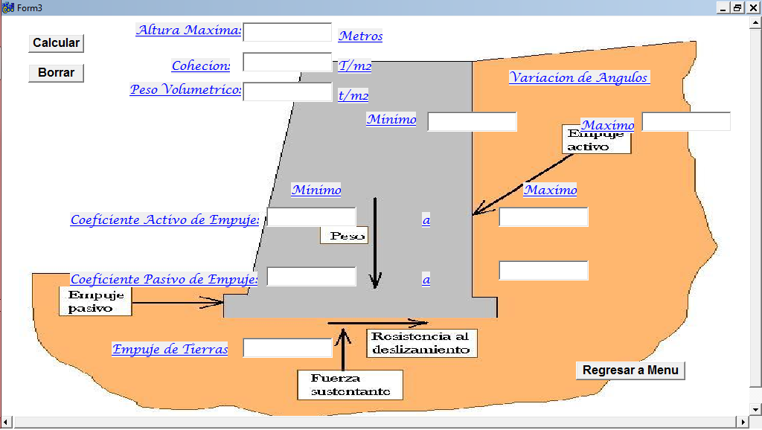

**PROGRAMACION**

//---------------------------------------------------------------------------

#include <vcl.h>

#pragma hdrstop

#include "Unit2.h"

#include "Unit3.h"

#include <math.h>

double AltMax, Cohe, PesoVol, AngMin, AngMax, Ka1, Ka2, Kp1, Kp2, Ea;

//---------------------------------------------------------------------------

#pragma package(smart_init)

#pragma resource "*.dfm"

TForm3 *Form3;

//---------------------------------------------------------------------------

__fastcall TForm3::TForm3(TComponent* Owner)

: TForm(Owner)

{

}

//---------------------------------------------------------------------------

void __fastcall TForm3::Button1Click(TObject *Sender)

{

AltMax=Edit1->Text.ToDouble();

Cohe=Edit2->Text.ToDouble();

PesoVol=Edit3->Text.ToDouble();

AngMin=Edit4->Text.ToDouble();

AngMax=Edit5->Text.ToDouble();

AngMin=AngMin*(M_PI/180);

AngMax=AngMax*(M_PI/180);

//Coeficientes

//Para los valores minimos

Ka1=(1-sin(AngMin))/(1+sin(AngMin));

Kp1=1/Ka1;

//Para los valores maximos

Ka2=(1-sin(AngMax))/(1+sin(AngMax));

Kp2=1/Ka2;

Edit6->Text=AnsiString(Ka1);

Edit7->Text=AnsiString(Ka2);

Edit8->Text=AnsiString(Kp1);

Edit9->Text=AnsiString(Kp2);

// Empuje de Tierras

Ea=(0.5)*(PesoVol*AltMax*AltMax)-2*(Cohe*AltMax);

Edit10->Text=AnsiString(Ea);

}

//---------------------------------------------------------------------------

void __fastcall TForm3::Button2Click(TObject *Sender)

{

Edit1->Text="";

Edit2->Text="";

Edit3->Text="";

Edit4->Text="";

Edit5->Text="";

Edit6->Text="";

Edit7->Text="";

Edit8->Text="";

Edit9->Text="";

Edit10->Text="";

}

//---------------------------------------------------------------------------

void __fastcall TForm3::Button3Click(TObject *Sender)

{

Form2->Show();

}

//---------------------------------------------------------------------------

**ESTABILIDAD DE LADERAS NATURALES**

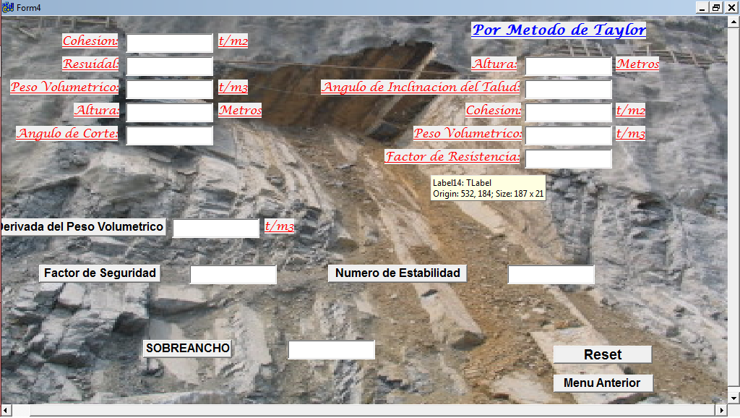

**PROGRAMACION**

//---------------------------------------------------------------------------

#include <vcl.h>

#pragma hdrstop

#include "Unit2.h"

#include "Unit4.h"

#include "Unit5.h"

#include <Math.h>

double Der, PesoVol, C, Res, FS, H, Ang, FactRes, c, Ne, X, h, ang;

//---------------------------------------------------------------------------

#pragma package(smart_init)

#pragma resource "*.dfm"

TForm4 *Form4;

//---------------------------------------------------------------------------

__fastcall TForm4::TForm4(TComponent* Owner)

: TForm(Owner)

{

}

//---------------------------------------------------------------------------

void __fastcall TForm4::Button2Click(TObject *Sender)

{

C=Edit1->Text.ToDouble();

Res=Edit2->Text.ToDouble();

PesoVol=Edit3->Text.ToDouble();

H=Edit4->Text.ToDouble();

Ang=Edit5->Text.ToDouble();

Der=Edit6->Text.ToDouble();

//conversion

Ang=Ang*(M_PI/180);

Res=Res*(M_PI/180);

FS=C/(PesoVol*H*(cos(Ang)*cos(Ang))*tan(Ang));

FS=FS+(Der/PesoVol)*(tan(Res)/tan(Ang));

Edit7->Text=AnsiString(FS);

}

//---------------------------------------------------------------------------

void __fastcall TForm4::Button3Click(TObject *Sender)

{

H=Edit8->Text.ToDouble();

PesoVol=Edit11->Text.ToDouble();

FactRes=Edit12->Text.ToDouble();

c=Edit10->Text.ToDouble();

Ne=((FactRes*c)/(PesoVol*H));

Edit13->Text=AnsiString(Ne);

ShowMessage("El angulo minimo del talud sera de 65.5°, para que este sea Estable");

}

//---------------------------------------------------------------------------

void __fastcall TForm4::Button7Click(TObject *Sender)

{

Form5->Show();

Edit9->Text="65";

Edit12->Text="0.6";

}

//---------------------------------------------------------------------------

void __fastcall TForm4::Button4Click(TObject *Sender)

{

ang=65.5;

h=7.0;

ang=ang*(M_PI/180);

X=h*(cos(ang));

Edit14->Text=AnsiString(X);

}

//---------------------------------------------------------------------------

void __fastcall TForm4::Button5Click(TObject *Sender)

{

Form2->Show();

}

//---------------------------------------------------------------------------

void __fastcall TForm4::Button6Click(TObject *Sender)

{

Edit1->Text="";

Edit2->Text="";

Edit3->Text="";

Edit4->Text="";

Edit5->Text="";

Edit6->Text="";

Edit7->Text="";

Edit8->Text="";

Edit9->Text="";

Edit10->Text="";

Edit11->Text="";

Edit12->Text="";

Edit13->Text="";

Edit14->Text="";

}

//---------------------------------------------------------------------------

void __fastcall TForm4::Button1Click(TObject *Sender)

{

PesoVol=Edit3->Text.ToDouble();

Der=1;

Der=PesoVol-Der;

Edit6->Text=AnsiString(Der);

}

//---------------------------------------------------------------------------