ALONZO OROZCO

FIC / UNACH

PROGRAMACION

PROYECTO INDIVIDUAL

DIDACTICA_2



Este programa está enfocado, a un juego de estudio donde se realizaran preguntas, donde el principal objetivo es que el jugador aprenda las leyes, conceptos y principios básicos de la física y todo aplicado a la ingeniería.



El juego contiene una interfaz muy interactiva y divertida, donde está relacionado al ámbito de la ingeniería civil, por lo cual también esta diseñado para todo el público general.

El objetivo de la física servirá para:

* Conocer y comprender los esquemas conceptuales básicos de la Física
* Conocer, comprender y dominar el uso de los métodos matemáticos y numéricos más comúnmente utilizados en Física.
* Tener una buena comprensión de las leyes físicas más importante
* Saber discutir conceptos, problemas y experimentos defendiendo con solidez y rigor científico sus argumentos

¿Cómo funciona el programa?

Al comenzar el programa saldrá una ventana principal en lo cual te mostrara opciones para poder comenzar a jugar, instrucciones o acerca del programa.

Al jugar el programa te ira haciendo distinta preguntas relacionado a la física y a la ingeniería civil, deberás ir contestando donde consideres que la respuesta es correcta.

Instrucciones dentro del programa.



1. Para comenzar a jugar pulsa el botón jugar.
2. Luego Pulsar el botón prueba mi conocimiento.
3. Aparecerán las preguntas que deberán contestar para poder seguir avanzando.
4. Si contesta correctamente se activara el botón siguiente y podrás seguir avanzando.
5. Si la repuesta no es correcta saldrá una ventada diciendo la respuesta es incorrecta inténtalo de nuevo seleccionando una respuesta diferente
6. Ahora si es la hora….

* Diviértete.
* Juega.
* Aprende.

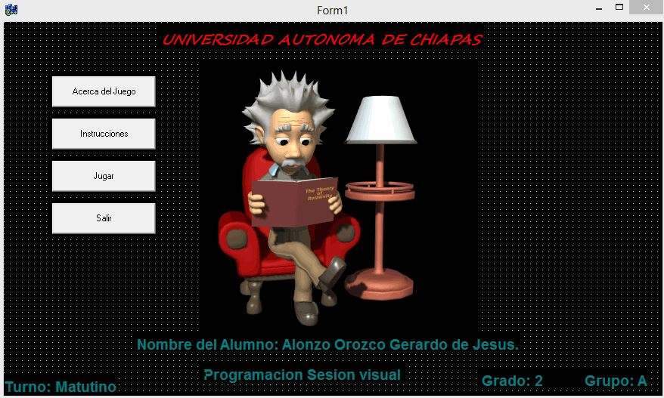

//---------------------------------------------------------------------------

#include <vcl.h>

#pragma hdrstop

#include "Unit1.h"

#include "Unit2.h"

#include "Unit3.h"

#include "Unit4.h"

//---------------------------------------------------------------------------

#pragma package(smart_init)

#pragma link "AniGIF_OCX"

#pragma resource "*.dfm"

TForm1 *Form1;

//---------------------------------------------------------------------------

__fastcall TForm1::TForm1(TComponent* Owner)

: TForm(Owner)

{

}

//---------------------------------------------------------------------------

void __fastcall TForm1::Button2Click(TObject *Sender)

{

Close();

}

//---------------------------------------------------------------------------

void __fastcall TForm1::Button3Click(TObject *Sender)

{

Form2->Show();

}

//---------------------------------------------------------------------------

void __fastcall TForm1::Button4Click(TObject *Sender)

{

Form3->Show();

}

//---------------------------------------------------------------------------

void __fastcall TForm1::Button1Click(TObject *Sender)

{

Form4->Show();

}

//---------------------------------------------------------------------------

void __fastcall TForm1::FormCreate(TObject *Sender)

{

gif->Play();

}

//---------------------------------------------------------------------------

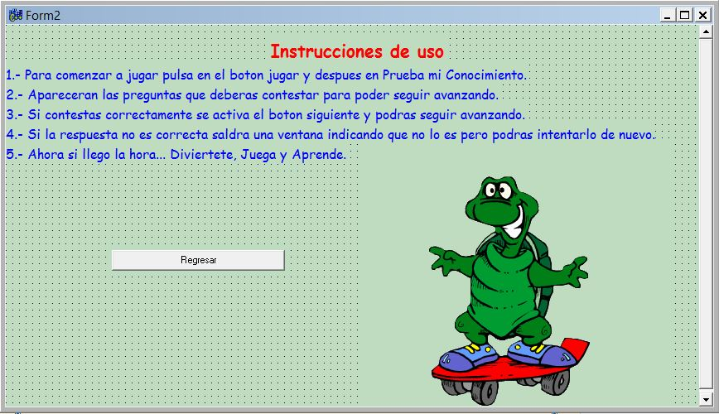

//---------------------------------------------------------------------------

#include <vcl.h>

#pragma hdrstop

#include "Unit2.h"

#include "Unit1.h"

//---------------------------------------------------------------------------

#pragma package(smart_init)

#pragma link "AniGIF_OCX"

#pragma resource "*.dfm"

TForm2 *Form2;

//---------------------------------------------------------------------------

__fastcall TForm2::TForm2(TComponent* Owner)

: TForm(Owner)

{

}

//---------------------------------------------------------------------------

void __fastcall TForm2::Button1Click(TObject *Sender)

{

Close();

}

//---------------------------------------------------------------------------

void __fastcall TForm2::FormCreate(TObject *Sender)

{

gif->Play();

}

//---------------------------------------------------------------------------

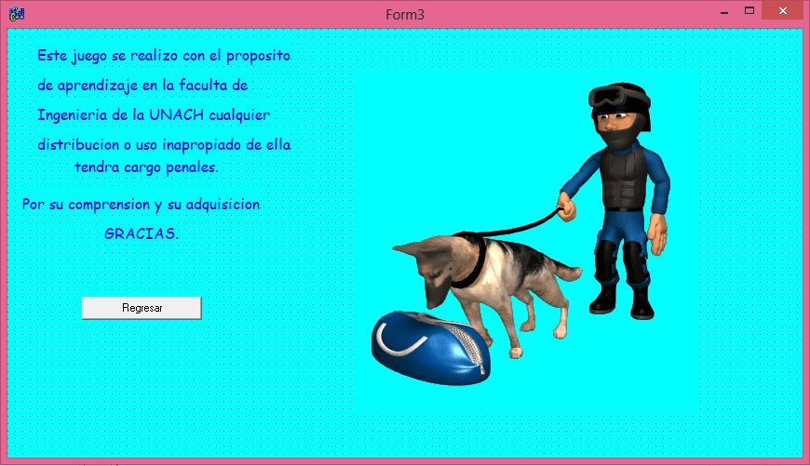

//---------------------------------------------------------------------------

#include <vcl.h>

#pragma hdrstop

#include "Unit3.h"

//---------------------------------------------------------------------------

#pragma package(smart_init)

#pragma link "AniGIF_OCX"

#pragma resource "*.dfm"

TForm3 *Form3;

//---------------------------------------------------------------------------

__fastcall TForm3::TForm3(TComponent* Owner)

: TForm(Owner)

{

}

//---------------------------------------------------------------------------

void __fastcall TForm3::Button1Click(TObject *Sender)

{

Close();

}

//---------------------------------------------------------------------------

void __fastcall TForm3::FormCreate(TObject *Sender)

{

gif->Play();

}

//---------------------------------------------------------------------------

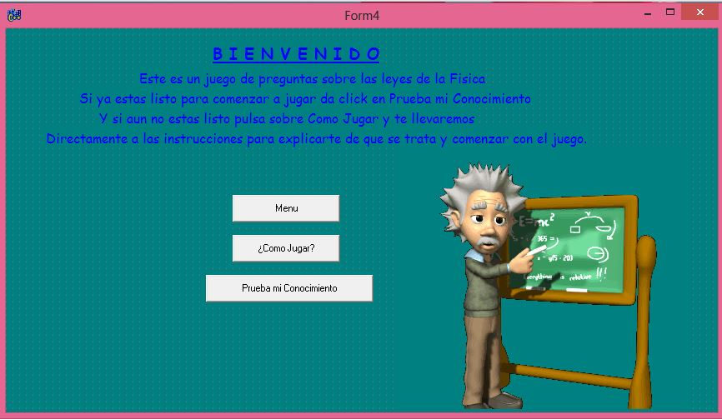

//---------------------------------------------------------------------------

#include <vcl.h>

#pragma hdrstop

#include "Unit4.h"

#include "Unit2.h"

#include "Unit5.h"

//---------------------------------------------------------------------------

#pragma package(smart_init)

#pragma link "AniGIF_OCX"

#pragma resource "*.dfm"

TForm4 *Form4;

//---------------------------------------------------------------------------

__fastcall TForm4::TForm4(TComponent* Owner)

: TForm(Owner)

{

}

//---------------------------------------------------------------------------

void __fastcall TForm4::Button1Click(TObject *Sender)

{

Form2->Show();

}

//---------------------------------------------------------------------------

void __fastcall TForm4::Button2Click(TObject *Sender)

{

Form5->Show();

Close();

}

//---------------------------------------------------------------------------

void __fastcall TForm4::Button3Click(TObject *Sender)

{

Close();

}

//---------------------------------------------------------------------------

void __fastcall TForm4::FormCreate(TObject *Sender)

{

gif->Play();

}

//---------------------------------------------------------------------------

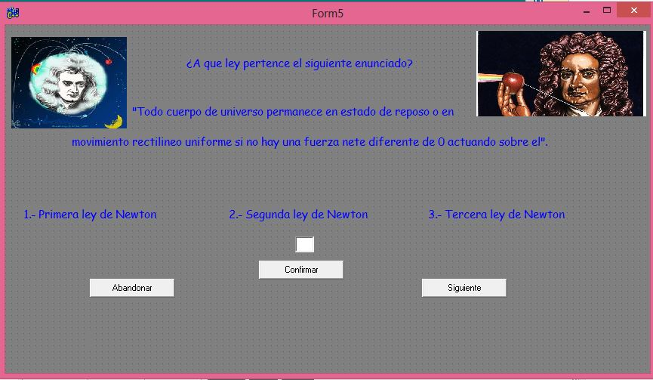

//---------------------------------------------------------------------------

#include <vcl.h>

#pragma hdrstop

#include "Unit5.h"

#include "Unit1.h"

#include "Unit8.h"

#include "Unit7.h"

//---------------------------------------------------------------------------

#pragma package(smart_init)

#pragma resource "*.dfm"

int a;

TForm5 *Form5;

//---------------------------------------------------------------------------

__fastcall TForm5::TForm5(TComponent* Owner)

: TForm(Owner)

{

}

//---------------------------------------------------------------------------

void __fastcall TForm5::Button1Click(TObject *Sender)

{

Form1->Show();

Close();

Label2->Caption="";

Edit1->Text="";

}

//---------------------------------------------------------------------------

void __fastcall TForm5::Button2Click(TObject *Sender)

{

a=Edit1->Text.ToInt();

if(a==1)

{

Label7->Caption="Tu respuesta es Correcta pulsar el botón siguiente ";

}

if(a==2)

{

Form7->Show();

}

if(a==3)

{

Form7->Show();

}

}

//---------------------------------------------------------------------------

void __fastcall TForm5::Button3Click(TObject *Sender)

{

if(a==1)

{

Form8->Show();

Close();

Label7->Caption="";

Edit1->Text="";

}

}

//---------------------------------------------------------------------------

void __fastcall TForm5::FormCreate(TObject *Sender)

{

}

//---------------------------------------------------------------------------

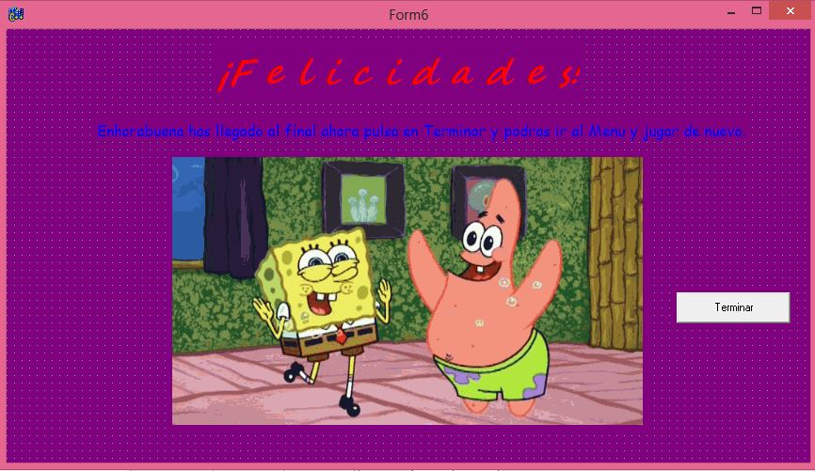

//---------------------------------------------------------------------------

#include <vcl.h>

#pragma hdrstop

#include "Unit6.h"

#include "Unit1.h"

#include "Unit8.h"

//---------------------------------------------------------------------------

#pragma package(smart_init)

#pragma link "AniGIF_OCX"

#pragma resource "*.dfm"

TForm6 *Form6;

//---------------------------------------------------------------------------

__fastcall TForm6::TForm6(TComponent* Owner)

: TForm(Owner)

{

}

//---------------------------------------------------------------------------

void __fastcall TForm6::Button1Click(TObject *Sender)

{

Form1->Show();

Close();

}

//---------------------------------------------------------------------------

void __fastcall TForm6::FormCreate(TObject *Sender)

{

gif->Play();

}

//-------------------------------------------------------------------

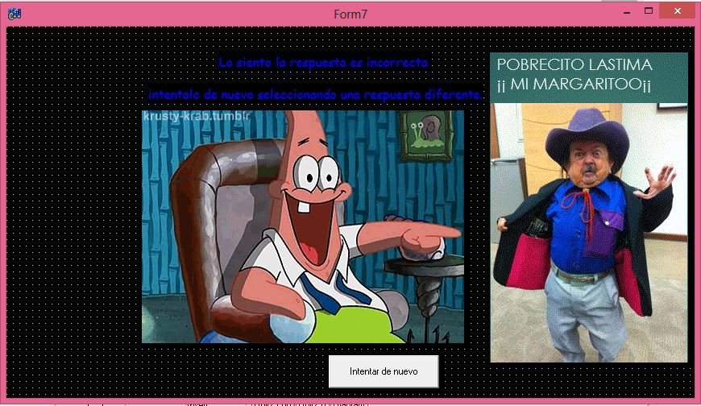

//---------------------------------------------------------------------------

#include <vcl.h>

#pragma hdrstop

#include "Unit7.h"

//---------------------------------------------------------------------------

#pragma package(smart_init)

#pragma link "AniGIF_OCX"

#pragma resource "*.dfm"

TForm7 *Form7;

//---------------------------------------------------------------------------

__fastcall TForm7::TForm7(TComponent* Owner)

: TForm(Owner)

{

}

//---------------------------------------------------------------------------

void __fastcall TForm7::Button1Click(TObject *Sender)

{

Close();

}

//---------------------------------------------------------------------------

void __fastcall TForm7::FormCreate(TObject *Sender)

{

gif->Play();

}

//---------------------------------------------------------------------------

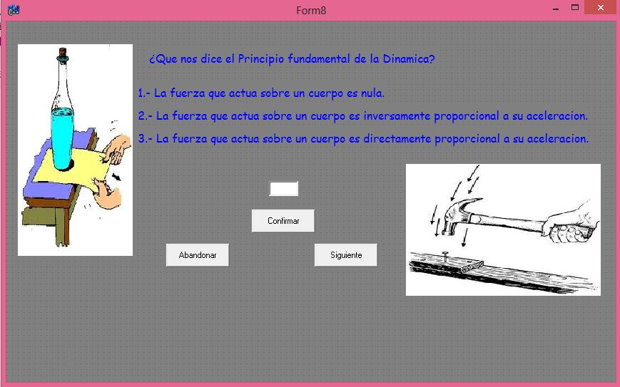

//---------------------------------------------------------------------------

#include <vcl.h>

#pragma hdrstop

#include "Unit8.h"

#include "Unit1.h"

#include "Unit7.h"

#include "Unit9.h"

//---------------------------------------------------------------------------

#pragma package(smart_init)

#pragma resource "*.dfm"

int a;

TForm8 *Form8;

//---------------------------------------------------------------------------

__fastcall TForm8::TForm8(TComponent* Owner)

: TForm(Owner)

{

}

//---------------------------------------------------------------------------

void __fastcall TForm8::Button1Click(TObject *Sender)

{

a=Edit2->Text.ToInt();

if(a==3)

{

Label5->Caption="Tu respuesta es Correcta pulsar el botón siguiente ";

}

if(a==2)

{

Form7->Show();

}

if(a==1)

{

Form7->Show();

}

}

//---------------------------------------------------------------------------

void __fastcall TForm8::Button2Click(TObject *Sender)

{

Form1->Show();

Close();

Label5->Caption="";

Edit2->Text="";

}

//---------------------------------------------------------------------------

void __fastcall TForm8::Button3Click(TObject *Sender)

{

if(a==3)

{

Form9->Show();

Close();

Label5->Caption="";

Edit2->Text="";

}

}

//---------------------------------------------------------------------------

void __fastcall TForm8::FormCreate(TObject *Sender)

{

}

//---------------------------------------------------------------------------

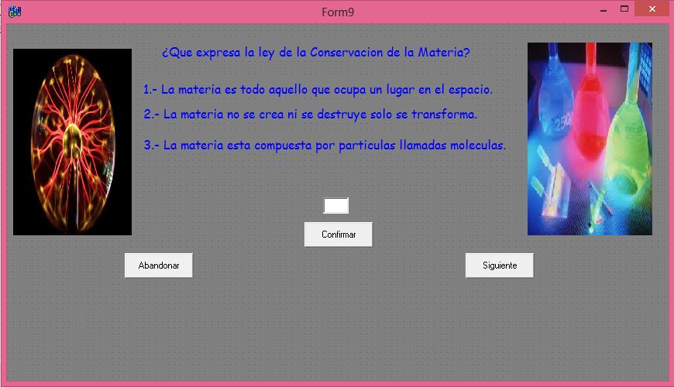

//---------------------------------------------------------------------------

#include <vcl.h>

#pragma hdrstop

#include "Unit9.h"

#include "Unit10.h"

#include "Unit7.h"

#include "Unit1.h"

//---------------------------------------------------------------------------

#pragma package(smart_init)

#pragma resource "*.dfm"

int a;

TForm9 *Form9;

//---------------------------------------------------------------------------

__fastcall TForm9::TForm9(TComponent* Owner)

: TForm(Owner)

{

}

//---------------------------------------------------------------------------

void __fastcall TForm9::Button2Click(TObject *Sender)

{

Form1->Show();

Close();

Label5->Caption="";

Edit1->Text="";

}

//---------------------------------------------------------------------------

void __fastcall TForm9::Button1Click(TObject *Sender)

{

a=Edit1->Text.ToInt();

if(a==2)

{

Label5->Caption="Tu respuesta es Correcta pulsar el boton siguiente ";

}

if(a==3)

{

Form7->Show();

}

if(a==1)

{

Form7->Show();

}

}

//---------------------------------------------------------------------------

void __fastcall TForm9::Button3Click(TObject *Sender)

{

if(a==2)

{

Form10->Show();

Close();

Label5->Caption="";

Edit1->Text="";

}

}

//---------------------------------------------------------------------------

void __fastcall TForm9::FormCreate(TObject *Sender)

{

}

//---------------------------------------------------------------------------

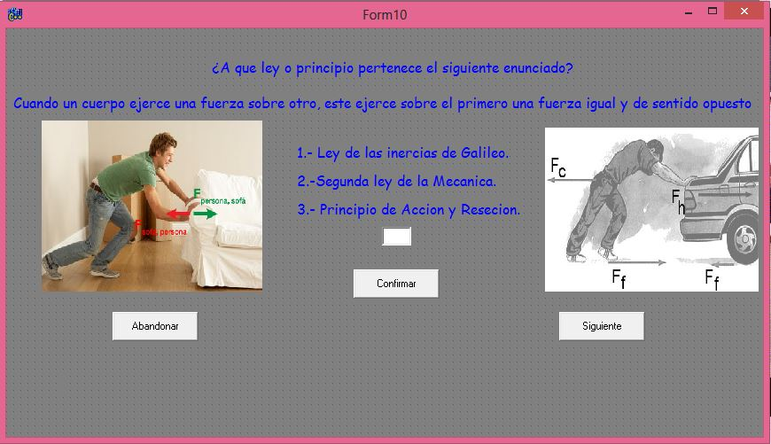

//---------------------------------------------------------------------------

#include <vcl.h>

#pragma hdrstop

#include "Unit10.h"

#include "Unit1.h"

#include "Unit7.h"

#include "Unit11.h"

//---------------------------------------------------------------------------

#pragma package(smart_init)

#pragma resource "*.dfm"

int a;

TForm10 *Form10;

//---------------------------------------------------------------------------

__fastcall TForm10::TForm10(TComponent* Owner)

: TForm(Owner)

{

}

//---------------------------------------------------------------------------

void __fastcall TForm10::Button2Click(TObject *Sender)

{

Form1->Show();

Close();

Label6->Caption="";

Edit1->Text="";

}

//---------------------------------------------------------------------------

void __fastcall TForm10::Button1Click(TObject *Sender)

{

a=Edit1->Text.ToInt();

if(a==3)

{

Label6->Caption="Tu respuesta es Correcta pulsar el botón siguiente ";

}

if(a==2)

{

Form7->Show();

}

if(a==1)

{

Form7->Show();

}

}

//---------------------------------------------------------------------------

void __fastcall TForm10::Button3Click(TObject *Sender)

{

if(a==3)

{

Form11->Show();

Close();

Label6->Caption="";

Edit1->Text="";

}

}

//---------------------------------------------------------------------------

void __fastcall TForm10::FormCreate(TObject *Sender)

{

}

//---------------------------------------------------------------------------

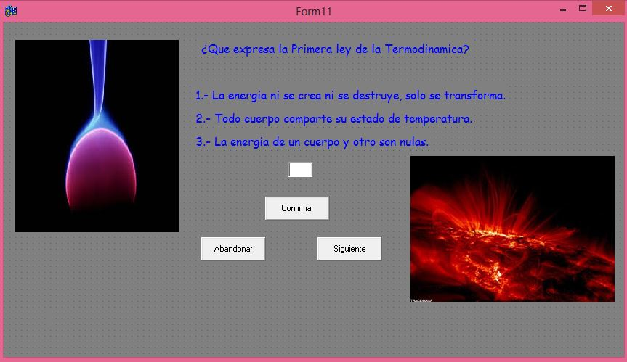

//---------------------------------------------------------------------------

#include <vcl.h>

#pragma hdrstop

#include "Unit11.h"

#include "Unit1.h"

#include "Unit7.h"

#include "Unit12.h"

//---------------------------------------------------------------------------

#pragma package(smart_init)

#pragma resource "*.dfm"

int a;

TForm11 *Form11;

//---------------------------------------------------------------------------

__fastcall TForm11::TForm11(TComponent* Owner)

: TForm(Owner)

{

}

//---------------------------------------------------------------------------

void __fastcall TForm11::Button2Click(TObject *Sender)

{

Form1->Show();

Close();

Label5->Caption="";

Edit1->Text="";

}

//---------------------------------------------------------------------------

void __fastcall TForm11::Button1Click(TObject *Sender)

{

a=Edit1->Text.ToInt();

if(a==1)

{

Label5->Caption="Tu respuesta es Correcta pulsar el botón siguiente ";

}

if(a==2)

{

Form7->Show();

}

if(a==3)

{

Form7->Show();

}

}

//---------------------------------------------------------------------------

void __fastcall TForm11::Button3Click(TObject *Sender)

{

if(a==1)

{

Form12->Show();

Close();

Label5->Caption="";

Edit1->Text="";

}

}

//---------------------------------------------------------------------------

void __fastcall TForm11::FormCreate(TObject *Sender)

{

}

//---------------------------------------------------------------------------

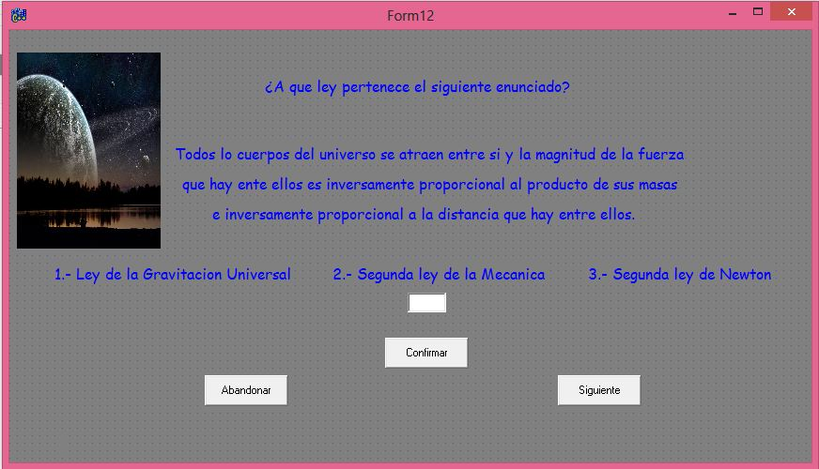

//---------------------------------------------------------------------------

#include <vcl.h>

#pragma hdrstop

#include "Unit12.h"

#include "Unit1.h"

#include "Unit7.h"

#include "Unit13.h"

//---------------------------------------------------------------------------

#pragma package(smart_init)

#pragma resource "*.dfm"

int a;

TForm12 *Form12;

//---------------------------------------------------------------------------

__fastcall TForm12::TForm12(TComponent* Owner)

: TForm(Owner)

{

}

//---------------------------------------------------------------------------

void __fastcall TForm12::Button2Click(TObject *Sender)

{

Form1->Show();

Close();

Label8->Caption="";

Edit1->Text="";

}

//---------------------------------------------------------------------------

void __fastcall TForm12::Button1Click(TObject *Sender)

{

a=Edit1->Text.ToInt();

if(a==1)

{

Label8->Caption="Tu respuesta es Correcta pulsar el botón siguiente ";

}

if(a==2)

{

Form7->Show();

}

if(a==3)

{

Form7->Show();

}

}

//---------------------------------------------------------------------------

void __fastcall TForm12::Button3Click(TObject *Sender)

{

if(a==1)

{

Form13->Show();

Close();

Label8->Caption="";

Edit1->Text="";

}

}

//---------------------------------------------------------------------------

void __fastcall TForm12::FormCreate(TObject *Sender)

{

}

//---------------------------------------------------------------------------

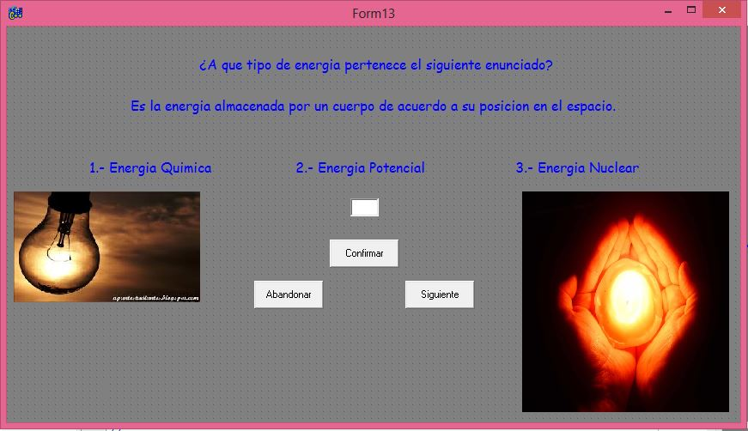

//---------------------------------------------------------------------------

#include <vcl.h>

#pragma hdrstop

#include "Unit13.h"

#include "Unit1.h"

#include "Unit7.h"

#include "Unit14.h"

//---------------------------------------------------------------------------

#pragma package(smart_init)

#pragma resource "*.dfm"

int a;

TForm13 *Form13;

//---------------------------------------------------------------------------

__fastcall TForm13::TForm13(TComponent* Owner)

: TForm(Owner)

{

}

//---------------------------------------------------------------------------

void __fastcall TForm13::Button2Click(TObject *Sender)

{

Form1->Show();

Close();

Label6->Caption="";

Edit1->Text="";

}

//---------------------------------------------------------------------------

void __fastcall TForm13::Button1Click(TObject *Sender)

{

a=Edit1->Text.ToInt();

if(a==2)

{

Label6->Caption="Tu respuesta es Correcta pulsar el botón siguiente ";

}

if(a==3)

{

Form7->Show();

}

if(a==1)

{

Form7->Show();

}

}

//---------------------------------------------------------------------------

void __fastcall TForm13::Button3Click(TObject *Sender)

{

if(a==2)

{

Form14->Show();

Close();

Label6->Caption="";

Edit1->Text="";

}

}

//---------------------------------------------------------------------------

void __fastcall TForm13::FormCreate(TObject *Sender)

{

}

//---------------------------------------------------------------------------

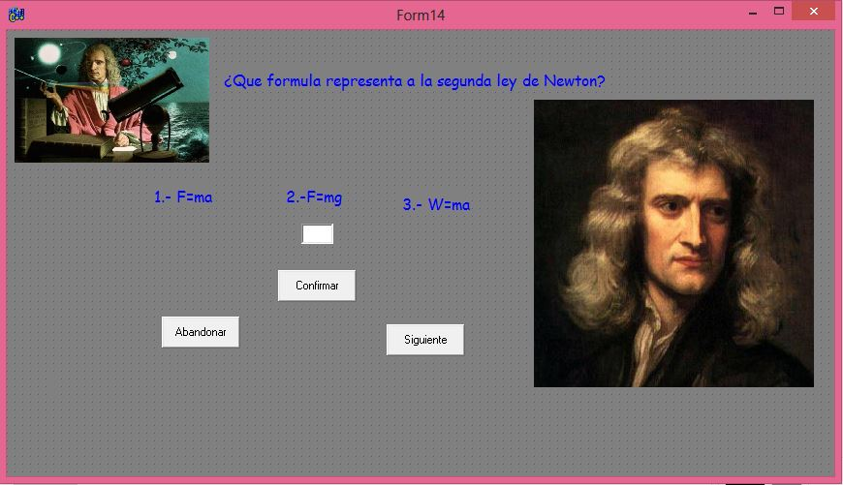

//---------------------------------------------------------------------------

#include <vcl.h>

#pragma hdrstop

#include "Unit14.h"

#include "Unit1.h"

#include "Unit7.h"

#include "Unit15.h"

//---------------------------------------------------------------------------

#pragma package(smart_init)

#pragma resource "*.dfm"

int a;

TForm14 *Form14;

//---------------------------------------------------------------------------

__fastcall TForm14::TForm14(TComponent* Owner)

: TForm(Owner)

{

}

//---------------------------------------------------------------------------

void __fastcall TForm14::Button1Click(TObject *Sender)

{

a=Edit1->Text.ToInt();

if(a==1)

{

Label5->Caption="Tu respuesta es Correcta pulsar el botón siguiente ";

}

if(a==2)

{

Form7->Show();

}

if(a==3)

{

Form7->Show();

}

}

//---------------------------------------------------------------------------

void __fastcall TForm14::Button2Click(TObject *Sender)

{

Form1->Show();

Close();

Label5->Caption="";

Edit1->Text="";

}

//---------------------------------------------------------------------------

void __fastcall TForm14::Button3Click(TObject *Sender)

{

if(a==1)

{

Form15->Show();

Close();

Label5->Caption="";

Edit1->Text="";

}

}

//---------------------------------------------------------------------------

void __fastcall TForm14::FormCreate(TObject *Sender)

{

}

//---------------------------------------------------------------------------

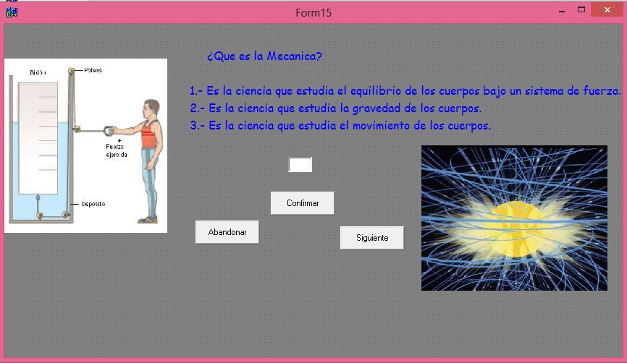

//---------------------------------------------------------------------------

#include <vcl.h>

#pragma hdrstop

#include "Unit15.h"

#include "Unit1.h"

#include "Unit7.h"

#include "Unit16.h"

//---------------------------------------------------------------------------

#pragma package(smart_init)

#pragma resource "*.dfm"

int a;

TForm15 *Form15;

//---------------------------------------------------------------------------

__fastcall TForm15::TForm15(TComponent* Owner)

: TForm(Owner)

{

}

//---------------------------------------------------------------------------

void __fastcall TForm15::Button2Click(TObject *Sender)

{

Form1->Show();

Close();

Label5->Caption="";

Edit1->Text="";

}

//---------------------------------------------------------------------------

void __fastcall TForm15::Button1Click(TObject *Sender)

{

a=Edit1->Text.ToInt();

if(a==3)

{

Label5->Caption="Tu respuesta es Correcta pulsar el botón siguiente ";

}

if(a==2)

{

Form7->Show();

}

if(a==1)

{

Form7->Show();

}

}

//---------------------------------------------------------------------------

void __fastcall TForm15::Button3Click(TObject *Sender)

{

if(a==3)

{

Form16->Show();

Close();

Label5->Caption="";

Edit1->Text="";

}

}

//---------------------------------------------------------------------------

void __fastcall TForm15::FormCreate(TObject *Sender)

{

}

//---------------------------------------------------------------------------

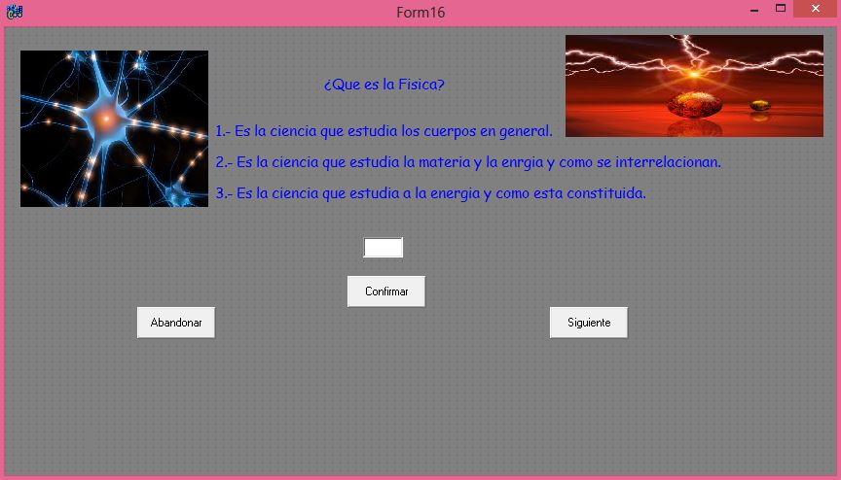

//---------------------------------------------------------------------------

#include <vcl.h>

#pragma hdrstop

#include "Unit16.h"

#include "Unit1.h"

#include "Unit7.h"

#include "Unit6.h"

//---------------------------------------------------------------------------

#pragma package(smart_init)

#pragma resource "*.dfm"

int a;

TForm16 *Form16;

//---------------------------------------------------------------------------

__fastcall TForm16::TForm16(TComponent* Owner)

: TForm(Owner)

{

}

//---------------------------------------------------------------------------

void __fastcall TForm16::Button2Click(TObject *Sender)

{

Form1->Show();

Close();

Label5->Caption="";

Edit1->Text="";

}

//---------------------------------------------------------------------------

void __fastcall TForm16::Button1Click(TObject *Sender)

{

a=Edit1->Text.ToInt();

if(a==2)

{

Label5->Caption="Tu respuesta es Correcta pulsar el botón siguiente ";

}

if(a==3)

{

Form7->Show();

}

if(a==1)

{

Form7->Show();

}

}

//---------------------------------------------------------------------------

void __fastcall TForm16::Button3Click(TObject *Sender)

{

if(a==2)

{

Form6->Show();

Close();

Label5->Caption="";

Edit1->Text="";

}

}

//---------------------------------------------------------------------------

void __fastcall TForm16::FormCreate(TObject *Sender)

{

}

//----------------------------------------------------------------------------