PROGRAMACION:

//---------------------------------------------------------------------------

#include <vcl.h>

#include <math.h>

#pragma hdrstop

#include "Unit1.h"

#include "Unit2.h"

#include "Unit3.h"

#include "Unit4.h"

//---------------------------------------------------------------------------

#pragma package(smart_init)

#pragma resource "*.dfm"

int numero, x, indice=0;

double sumatoria=0, sumatoria1=0, media, varianza, destan;

float muestra[100000];

TForm1 *Form1;

//---------------------------------------------------------------------------

__fastcall TForm1::TForm1(TComponent* Owner)

: TForm(Owner)

{

}

//---------------------------------------------------------------------------

void __fastcall TForm1::Button2Click(TObject *Sender)

{

if (indice<numero)

{

Form2->limpiar();

Form2->ShowModal();

if(Form2->obtenresultado1()!=0 && indice<numero)

{

muestra[indice] = Form2->obtenresultado1();

ListBox1->Items->Add(muestra[indice]);

indice++;

if(indice >= numero)

Button5->Enabled = true;

Button2->Enabled = false;

Button3->Enabled = false;

Button4->Enabled = false;

}

if(Form2->obtenresultado2()!=0 && indice<numero)

{

muestra[indice] = Form2->obtenresultado2();

ListBox1->Items->Add(muestra[indice]);

indice++;

if(indice >= numero)

Button5->Enabled = true;

Button2->Enabled = false;

Button3->Enabled = false;

Button4->Enabled = false;

}

}

}

//---------------------------------------------------------------------------

void __fastcall TForm1::Button1Click(TObject *Sender)

{

Close();

}

//---------------------------------------------------------------------------

void __fastcall TForm1::Button3Click(TObject *Sender)

{

if (indice<numero)

{

Form3->limpiar();

Form3->ShowModal();

if(Form3->obtenresultado1()!=0 && indice<numero)

{

muestra[indice] = Form3->obtenresultado1();

ListBox1->Items->Add(muestra[indice]);

indice++;

if(indice >= numero)

Button5->Enabled = true;

Button2->Enabled = false;

Button3->Enabled = false;

Button4->Enabled = false;

}

if(Form3->obtenresultado2()!=0 && indice<numero)

{

muestra[indice] = Form3->obtenresultado2();

ListBox1->Items->Add(muestra[indice]);

indice++;

if(indice >= numero)

Button5->Enabled = true;

Button2->Enabled = false;

Button3->Enabled = false;

Button4->Enabled = false;

}

}

}

//---------------------------------------------------------------------------

void __fastcall TForm1::Button4Click(TObject *Sender)

{

if (indice<numero)

{

Form4->limpiar();

Form4->ShowModal();

if(Form4->obtenresultado1()!=0 && indice<numero)

{

muestra[indice] = Form4->obtenresultado1();

ListBox1->Items->Add(muestra[indice]);

indice++;

if(indice >= numero)

Button5->Enabled = true;

Button2->Enabled = false;

Button3->Enabled = false;

Button4->Enabled = false;

}

if(Form4->obtenresultado2()!=0 && indice<numero)

{

muestra[indice] = Form4->obtenresultado2();

ListBox1->Items->Add(muestra[indice]);

indice++;

if(indice >= numero)

Button5->Enabled = true;

Button2->Enabled = false;

Button3->Enabled = false;

Button4->Enabled = false;

}

}

}

//---------------------------------------------------------------------------

void __fastcall TForm1::Edit1Change(TObject *Sender)

{

if(Edit1->Text != "")

numero=Edit1->Text.ToInt();

if(Button2->Enabled == false && Edit1->Text != "")

{

Button2->Enabled = true;

Button3->Enabled = true;

Button4->Enabled = true;

}

else if(Button2->Enabled == true && Edit1->Text == "")

{

Button2->Enabled = false;

Button3->Enabled = false;

Button4->Enabled = false;

}

}

//---------------------------------------------------------------------------

void __fastcall TForm1::Button5Click(TObject *Sender)

{

for (x=0; x<numero ; x++)

{ sumatoria=sumatoria+muestra[x]; };

media= sumatoria/numero;

for (x=0; x<numero ; x++)

{ sumatoria1= pow((muestra[x]-media),2); };

varianza= sumatoria1/numero;

Edit2->Text=AnsiString(varianza);

destan=sqrt (varianza);

Edit3->Text=AnsiString(destan);

}

//---------------------------------------------------------------------------

Form1

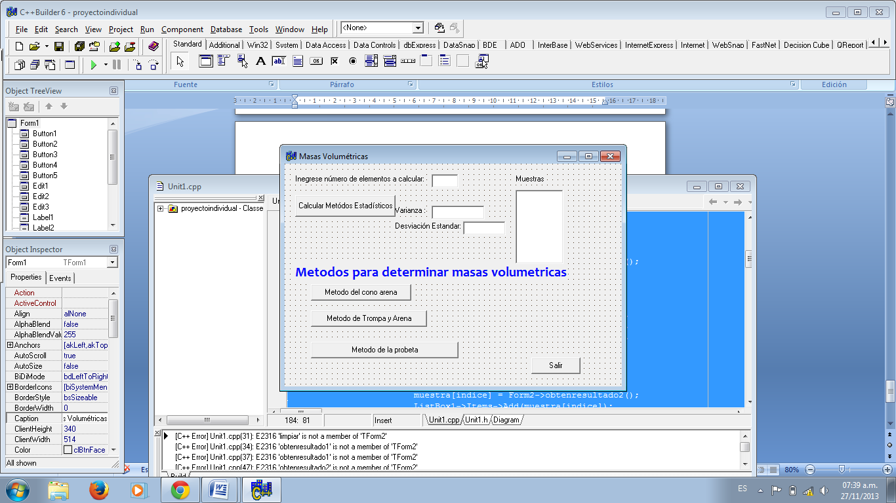

Form2

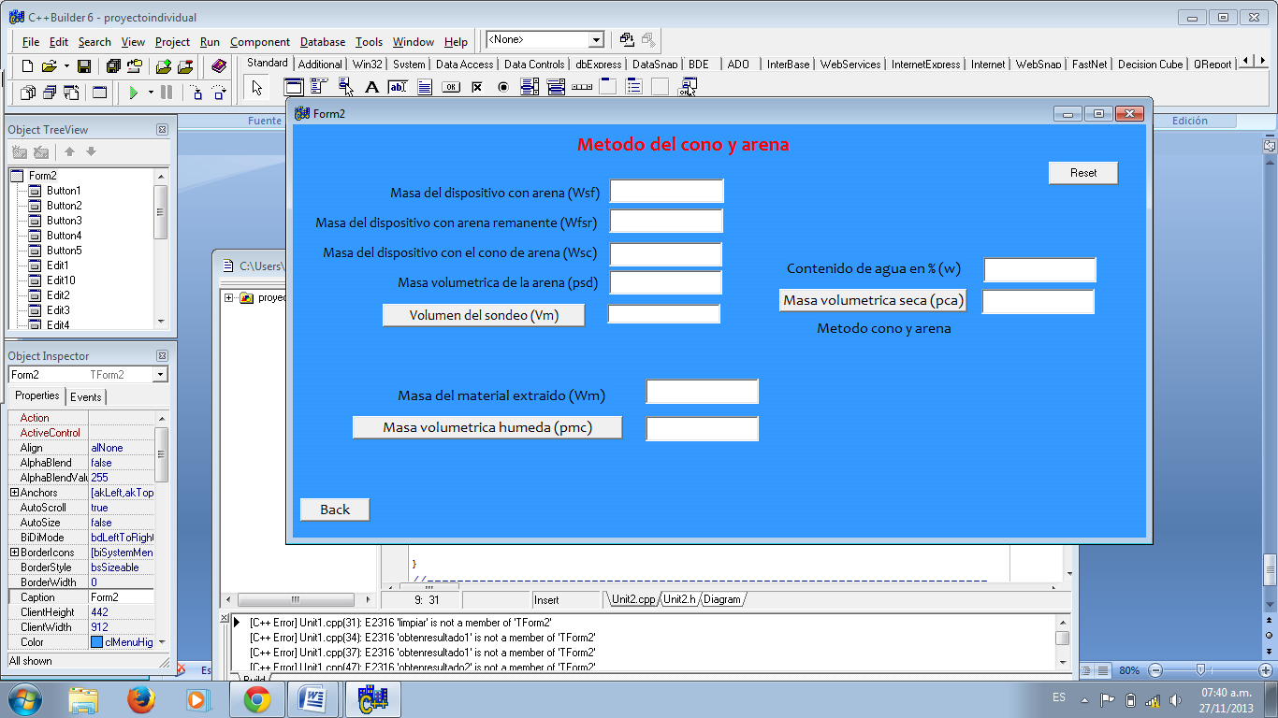

Form3

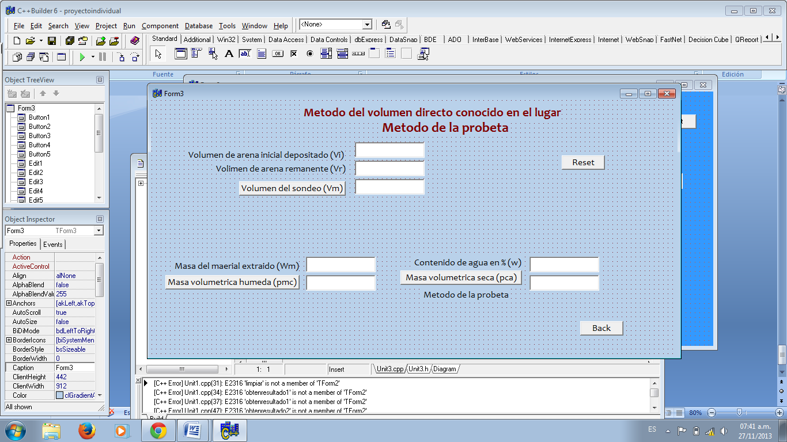

Form4

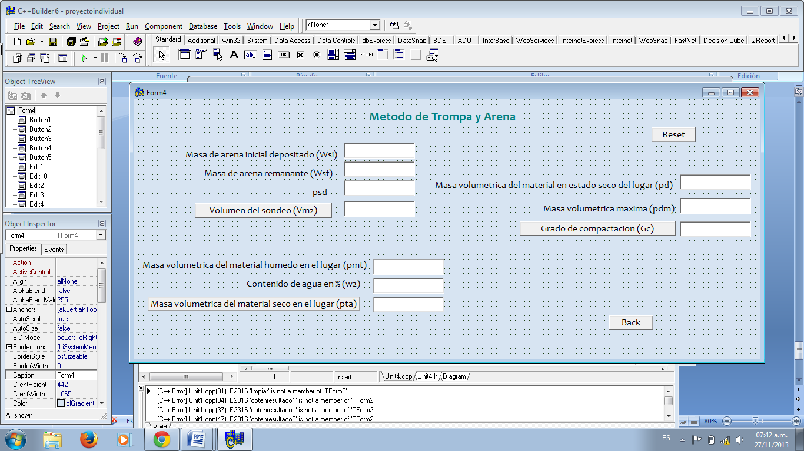

**PROGRAMACION: 2° Programa**

**Programacion de Form1**

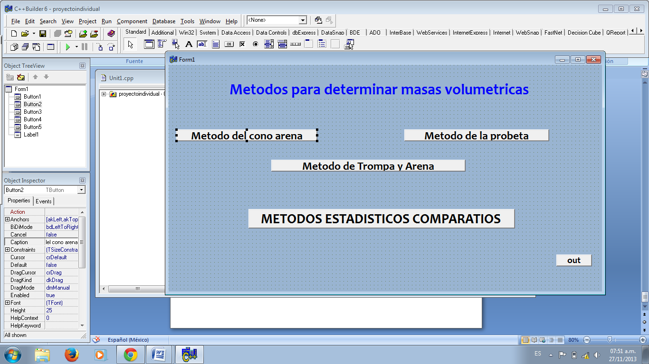

//---------------------------------------------------------------------------

#include <vcl.h>

#pragma hdrstop

#include "Unit1.h"

//---------------------------------------------------------------------------

#pragma package(smart_init)

#pragma resource "*.dfm"

TForm1 *Form1;

TForm1 *Form2;

TForm1 *Form3;

TForm1 *Form4;

TForm1 *Form5;

//---------------------------------------------------------------------------

__fastcall TForm1::TForm1(TComponent* Owner)

: TForm(Owner)

{

}

//---------------------------------------------------------------------------

void __fastcall TForm1::Button2Click(TObject *Sender)

{

Form2->Show();

}

//---------------------------------------------------------------------------

void __fastcall TForm1::Button1Click(TObject *Sender)

{

Close();

}

//---------------------------------------------------------------------------

void __fastcall TForm1::Button3Click(TObject *Sender)

{

Form3->Show();

}

//---------------------------------------------------------------------------

void __fastcall TForm1::Button4Click(TObject *Sender)

{

Form4->Show();

}

//---------------------------------------------------------------------------

void __fastcall TForm1::Button5Click(TObject *Sender)

{

Form5->Show();

}

//---------------------------------------------------------------------------

Programacion de Form 2

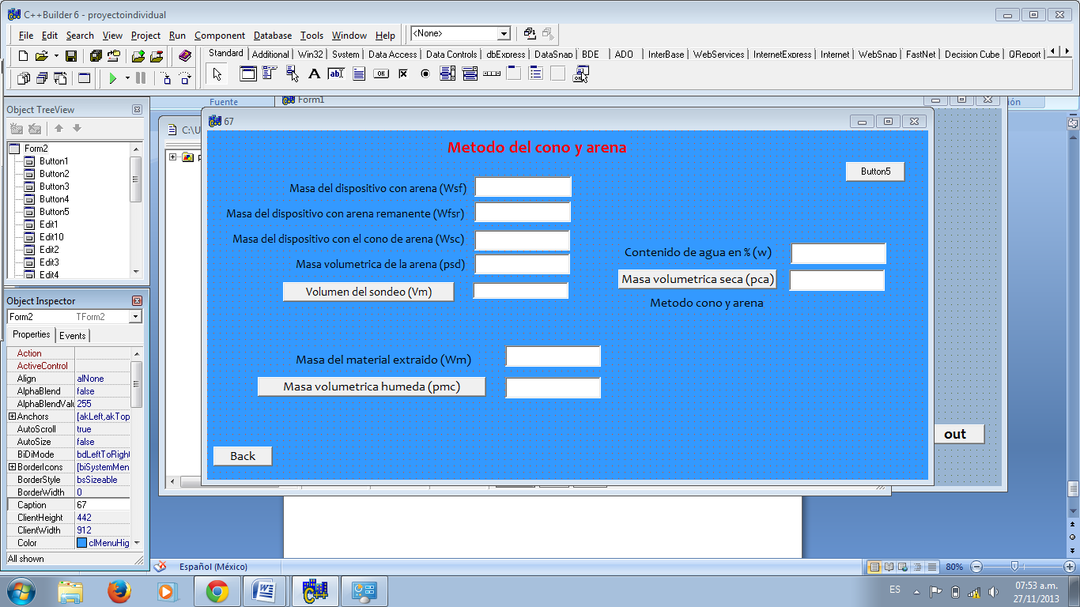

//---------------------------------------------------------------------------

#include <vcl.h>

#pragma hdrstop

#include "Unit2.h"

//---------------------------------------------------------------------------

#pragma package(smart_init)

#pragma resource "*.dfm"

double Wsf, Wfsr, Wsc, psd, Vm, Wm, pmc,w, pca;

TForm2 *Form2;

//---------------------------------------------------------------------------

__fastcall TForm2::TForm2(TComponent* Owner)

: TForm(Owner)

{

}

//---------------------------------------------------------------------------

void __fastcall TForm2::Button2Click(TObject *Sender)

{

Close();

}

//---------------------------------------------------------------------------

void __fastcall TForm2::Button1Click(TObject *Sender)

{

Wsf=Edit1->Text.ToDouble();

Wfsr=Edit2->Text.ToDouble();

Wsc=Edit3->Text.ToDouble();

psd=Edit4->Text.ToDouble();

Vm= ((Wsf-Wfsr)- Wsc)/psd;

Vm= Vm*100;

Edit5->Text=AnsiString(Vm);

}

//---------------------------------------------------------------------------

void __fastcall TForm2::Button3Click(TObject *Sender)

{

Wm=Edit6->Text.ToDouble();

pmc= (Wm/Vm)*100;

Edit8->Text=AnsiString(pmc);

}

//---------------------------------------------------------------------------

void __fastcall TForm2::Button4Click(TObject *Sender)

{

w=Edit9->Text.ToDouble();

pca= (pmc*100)/(100+w);

Edit10->Text=AnsiString(pca);

}

//---------------------------------------------------------------------------

void __fastcall TForm2::Button5Click(TObject *Sender)

{

Edit1->Text="";

Edit2->Text="";

Edit3->Text="";

Edit4->Text="";

Edit5->Text="";

Edit6->Text="";

Edit10->Text="";

Edit8->Text="";

Edit9->Text="";

}

//---------------------------------------------------------------------------

Programacion de Form3

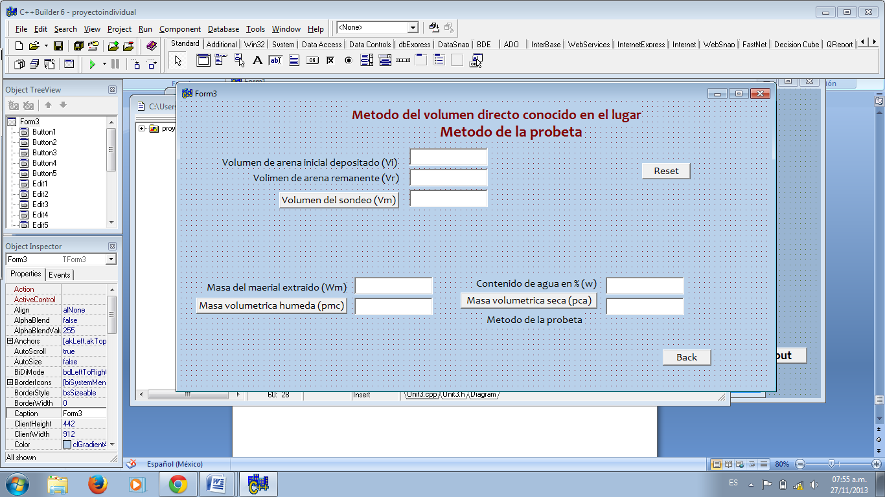

//---------------------------------------------------------------------------

#include <vcl.h>

#pragma hdrstop

#include "Unit3.h"

//---------------------------------------------------------------------------

#pragma package(smart_init)

#pragma resource "*.dfm"

double Vi, Vr, Vm1, Wm1, pmc1, w1, pca1;

TForm3 *Form3;

//---------------------------------------------------------------------------

__fastcall TForm3::TForm3(TComponent* Owner)

: TForm(Owner)

{

}

//---------------------------------------------------------------------------

void __fastcall TForm3::Button1Click(TObject *Sender)

{

Vi=Edit1->Text.ToDouble();

Vr=Edit2->Text.ToDouble();

Vm1= Vi-Vr;

Edit3->Text=AnsiString(Vm1);

}

//---------------------------------------------------------------------------

void __fastcall TForm3::Button2Click(TObject *Sender)

{

Wm1=Edit4->Text.ToDouble();

pmc1= (Wm1/Vm1)*100;

Edit5->Text=AnsiString(pmc1);

}

//---------------------------------------------------------------------------

void __fastcall TForm3::Button3Click(TObject *Sender)

{

w1=Edit6->Text.ToDouble();

pca1= (pmc1*100)/(100+w1);

Edit7->Text=AnsiString(pca1);

}

//---------------------------------------------------------------------------

void __fastcall TForm3::Button4Click(TObject *Sender)

{

Close();

}

//---------------------------------------------------------------------------

void __fastcall TForm3::Button5Click(TObject *Sender)

{

Edit1->Text="";

Edit2->Text="";

Edit3->Text="";

Edit4->Text="";

Edit5->Text="";

Edit6->Text="";

Edit7->Text="";

}

//---------------------------------------------------------------------------

Programacion de Form4

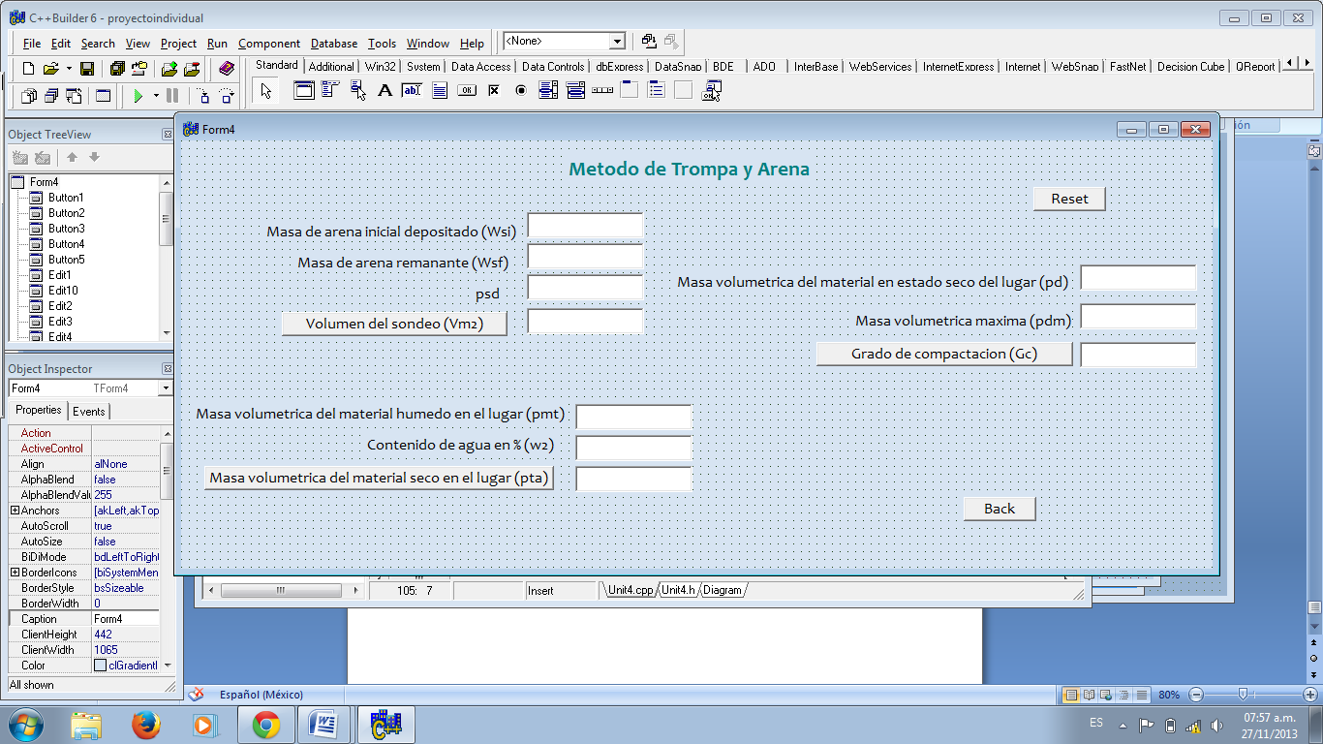

//---------------------------------------------------------------------------

#include <vcl.h>

#pragma hdrstop

#include "Unit4.h"

//---------------------------------------------------------------------------

#pragma package(smart_init)

#pragma resource "*.dfm"

double Wsi, Wsf, psd, Vm2, pmt, w2, pta, pd, pdm, Gc;

TForm4 *Form4;

//---------------------------------------------------------------------------

__fastcall TForm4::TForm4(TComponent* Owner)

: TForm(Owner)

{

}

//---------------------------------------------------------------------------

void __fastcall TForm4::Button1Click(TObject *Sender)

{

Wsi=Edit1->Text.ToDouble();

Wsf=Edit2->Text.ToDouble();

psd=Edit10->Text.ToDouble();

Vm2= (Wsi-Wsf)/psd;

Vm2= (Vm2)*1000;

Edit3->Text=AnsiString(Vm2);

}

//---------------------------------------------------------------------------

void __fastcall TForm4::Button2Click(TObject *Sender)

{

pmt=Edit4->Text.ToDouble();

w2=Edit5->Text.ToDouble();

pta= pmt/(100+w2);

pta= pta*1000;

Edit6->Text=AnsiString(pta);

}

//---------------------------------------------------------------------------

void __fastcall TForm4::Button3Click(TObject *Sender)

{

pd=Edit7->Text.ToDouble();

pdm=Edit8->Text.ToDouble();

Gc= (pd*100)/pdm;

Edit9->Text=AnsiString(Gc);

}

//---------------------------------------------------------------------------

void __fastcall TForm4::Button4Click(TObject *Sender)

{

Close();

}

//---------------------------------------------------------------------------

void __fastcall TForm4::Button5Click(TObject *Sender)

{

Edit1->Text="";

Edit2->Text="";

Edit3->Text="";

Edit4->Text="";

Edit5->Text="";

Edit6->Text="";

Edit7->Text="";

Edit8->Text="";

Edit9->Text="";

Edit10->Text="";

}

//---------------------------------------------------------------------------

Programacion de Form5

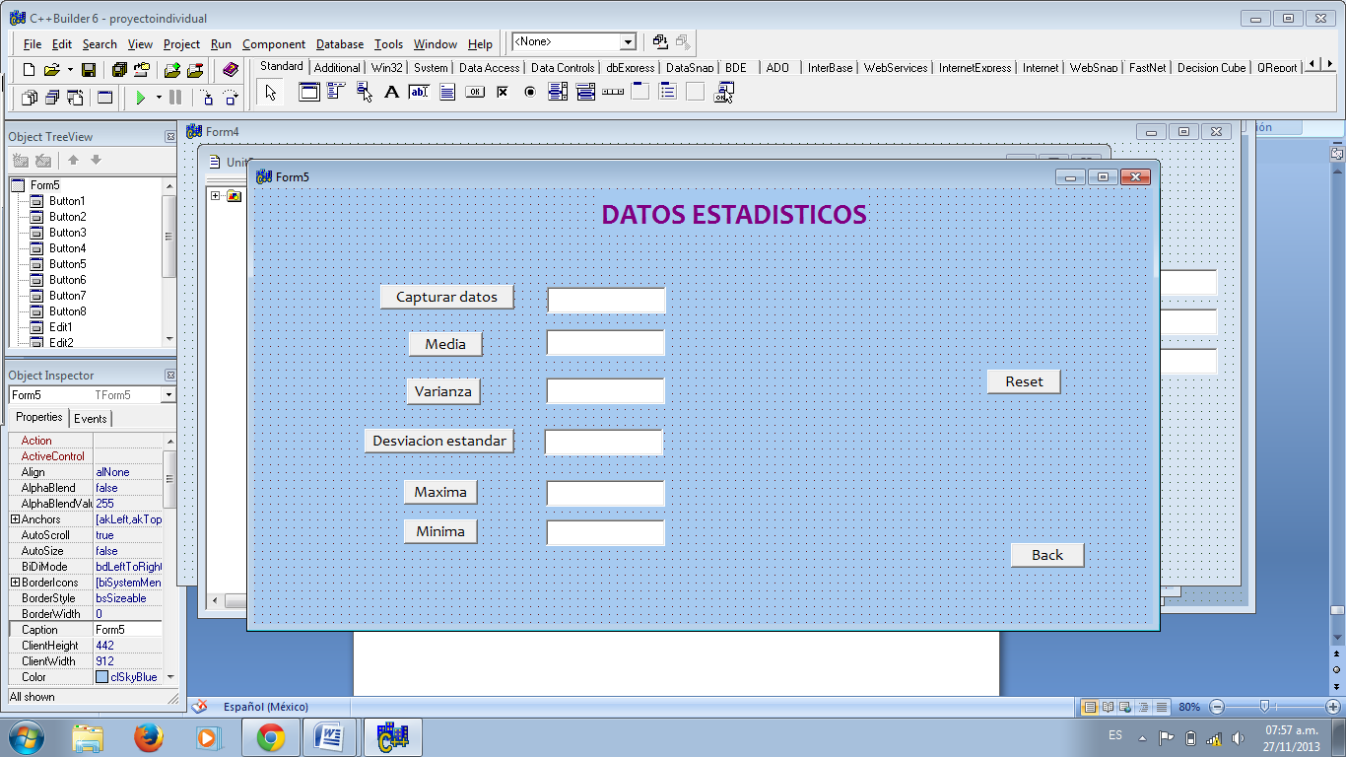

//---------------------------------------------------------------------------

#include <vcl.h>

#pragma hdrstop

#include "Unit5.h"

//---------------------------------------------------------------------------

#pragma package(smart_init)

#pragma resource "*.dfm"

#include <math.h>

int i=1,s,n,k,q,c;

double A[100],med,sum,pum,bar,rex,S,a;

TForm5 *Form5;

//---------------------------------------------------------------------------

__fastcall TForm5::TForm5(TComponent* Owner)

: TForm(Owner)

{

}

//---------------------------------------------------------------------------

void __fastcall TForm5::Button1Click(TObject *Sender)

{

A[i]=Edit1->Text.ToDouble();

Edit1->Text="";

Edit1->SetFocus();

i++;

}

//---------------------------------------------------------------------------

void __fastcall TForm5::Button2Click(TObject *Sender)

{

n=i-1;

sum=0;

for(s=1; s<=n; s++){

sum=sum+A[s];

}

med=sum/n;

Edit2->Text=AnsiString(med);

}

//---------------------------------------------------------------------------

void __fastcall TForm5::Button3Click(TObject *Sender)

{

n=i-1;

pum=0;

for(k=1; k<=n; k++){

rex=med-A[k];

rex=rex*rex;

pum=pum+rex;

}

bar=pum/n;

Edit3->Text=AnsiString(bar);

}

//---------------------------------------------------------------------------

void __fastcall TForm5::Button4Click(TObject *Sender)

{

S= pow(bar,0.5);

Edit4->Text=AnsiString(S);

}

//---------------------------------------------------------------------------

void __fastcall TForm5::Button7Click(TObject *Sender)

{

Close();

}

//---------------------------------------------------------------------------

void __fastcall TForm5::Button5Click(TObject *Sender)

{

q=1;

n=i-1;

a=A[q];

for (c=2;c<=n;c++){

q++;

if (a<=A[q]) {a=A[q];} }

Edit5->Text=AnsiString(a);

}

//---------------------------------------------------------------------------

void __fastcall TForm5::Button6Click(TObject *Sender)

{

q=1;

n=i-1;

a=A[q];

for (c=2;c<=n;c++){

q++;

if (a>=A[q]) {a=A[q];} }

Edit6->Text=AnsiString(a);

}

//---------------------------------------------------------------------------

void __fastcall TForm5::Button8Click(TObject *Sender)

{

Edit1->Text="";

Edit2->Text="";

Edit3->Text="";

Edit4->Text="";

Edit5->Text="";

Edit6->Text="";

Edit1->SetFocus();

i=1;

}

//---------------------------------------------------------------------------